1 If your Pi does not have a Wifi Dongle then you can still connect it to your Wifi network using your PC as a Bridge. This will allow the Pi to send traffic through the Ethernet port to the PC and then out onto your Wifi network – effectively using the PC as a “Bridge”

*You can use this method as an alternative to setting a Static IP address on both the Pi and the Lan Connection.*

2 Go to the Control Panel and Open the Network and Sharing Centre

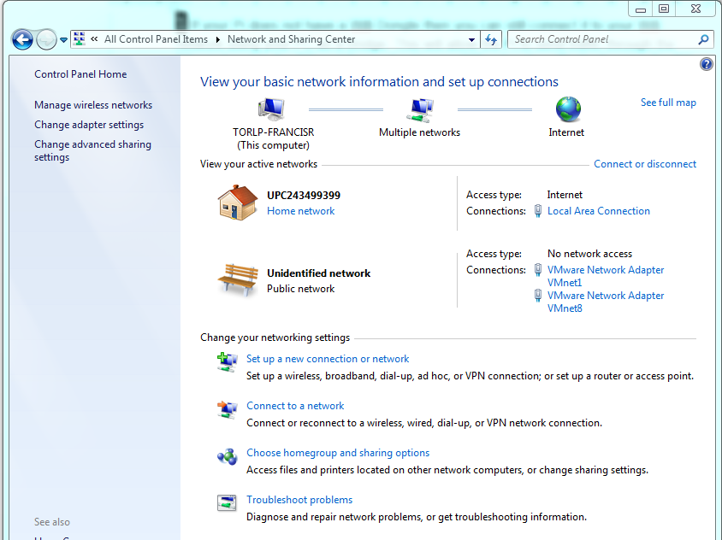

3 Now click on Change Adapter Settings to return a list of adapters on your PC.

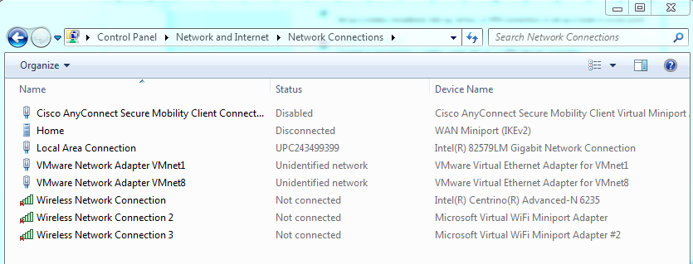

4 Now **hold down** the Cntrl-Key *while* you **right-click** the Local Area Connection (which is where the Pi will be connected) and the Wireless Network Connection (which connects to your Router and the outside world)

This highlights the connections you want to bridge.

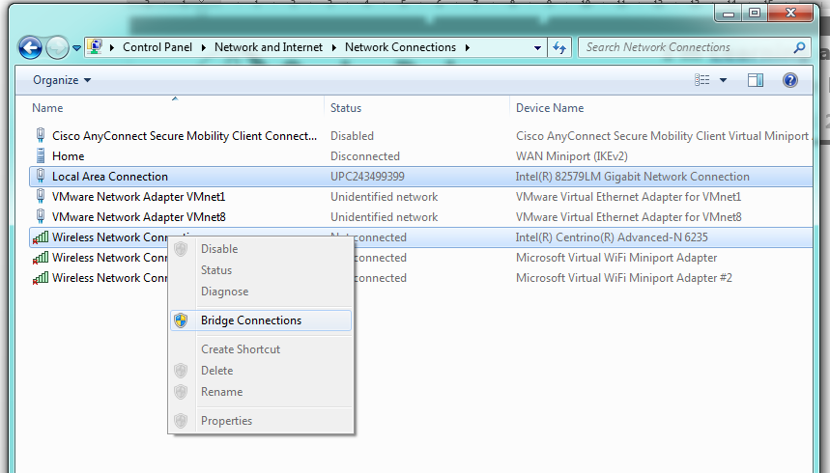

This creates a new Network Bridge.

4 Now right-click to bring up the menu that has the Bridge Connection option and click **Bridge connections**

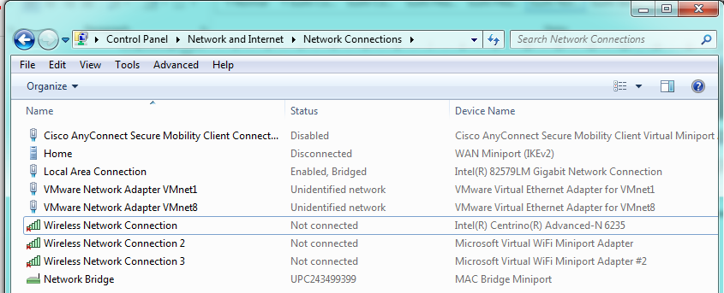

Both machines should now have an IP address supplied by your router, with the Wifi network connection of the PC providing access to the outside world with your Pi!